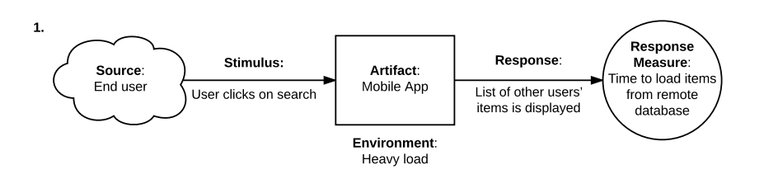

**Risk**: The actual system response may not fulfil the ASR requirement of < 1 sec when there is heavy load in the operating environment, high network latency or the search function is complex.

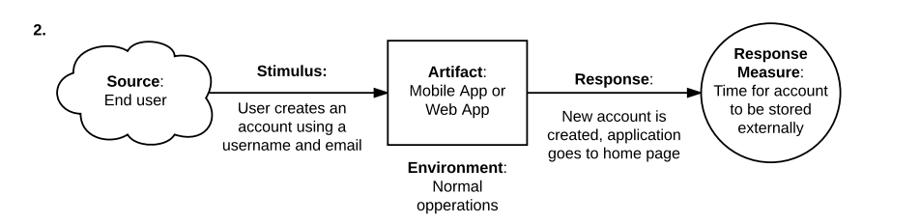

**Risk:** Creating an account using both username and email is not a good security practise. Account should be created with username/email AND a password. And depending on security measures implemented at the external storage such as data at rest encryption and API authentication, the response time for account creation can be long.

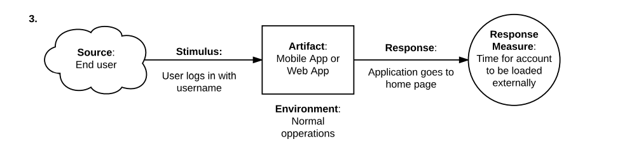

**Sensitivity Point:** The response time for the account to be loaded can be affected by the speed of authentication, which in turn is affected by the number of communications between the different web services. Also, the security of the authentication process must also be looked into.

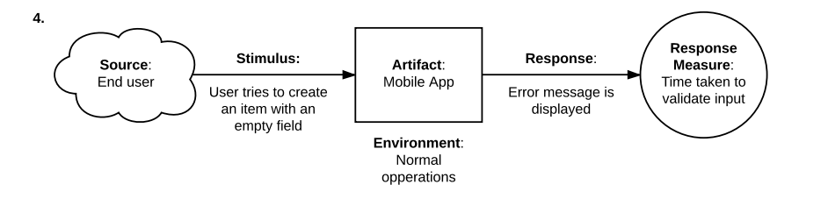

**Non-risk**: The operation is performing as expected where the application validates the input and display the appropriate message.

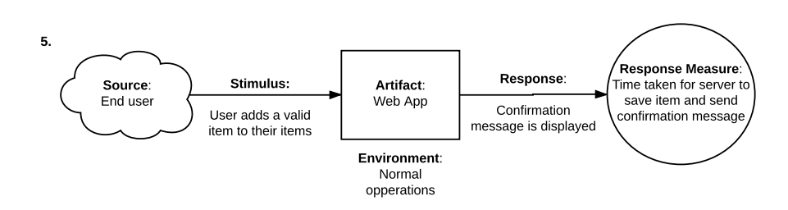

**Non-risk**: The operation is performing as expected where the application validates the input and display the appropriate message.

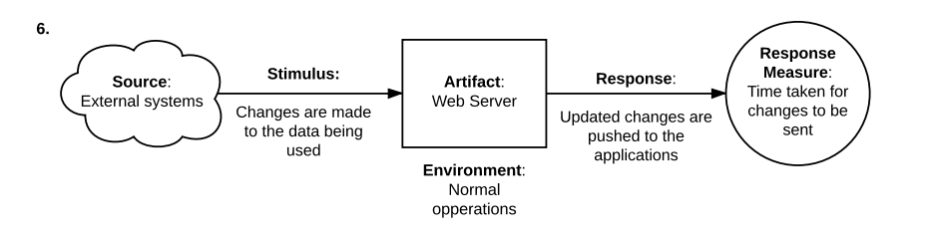

**Sensitivity Point**: Consider enhancement the design to first ensure the changes are done on the latest data version. Hence, it’s better for the data to be pulled from the server first before the changes are made at the external systems.

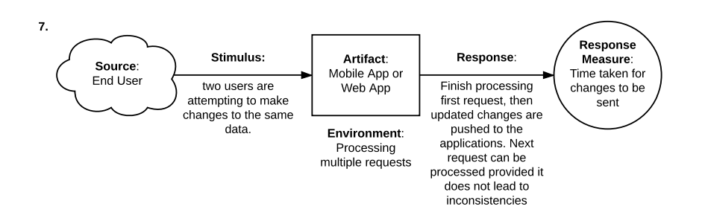

**Risk**: Concurrent update requests are actually handled sequentially as described and the later data change request will almost certainly take >1 seconds to complete processing.

**Updated Utility Tree**



Note: Boxes in orange colour are edits to the original Utility Tree.